
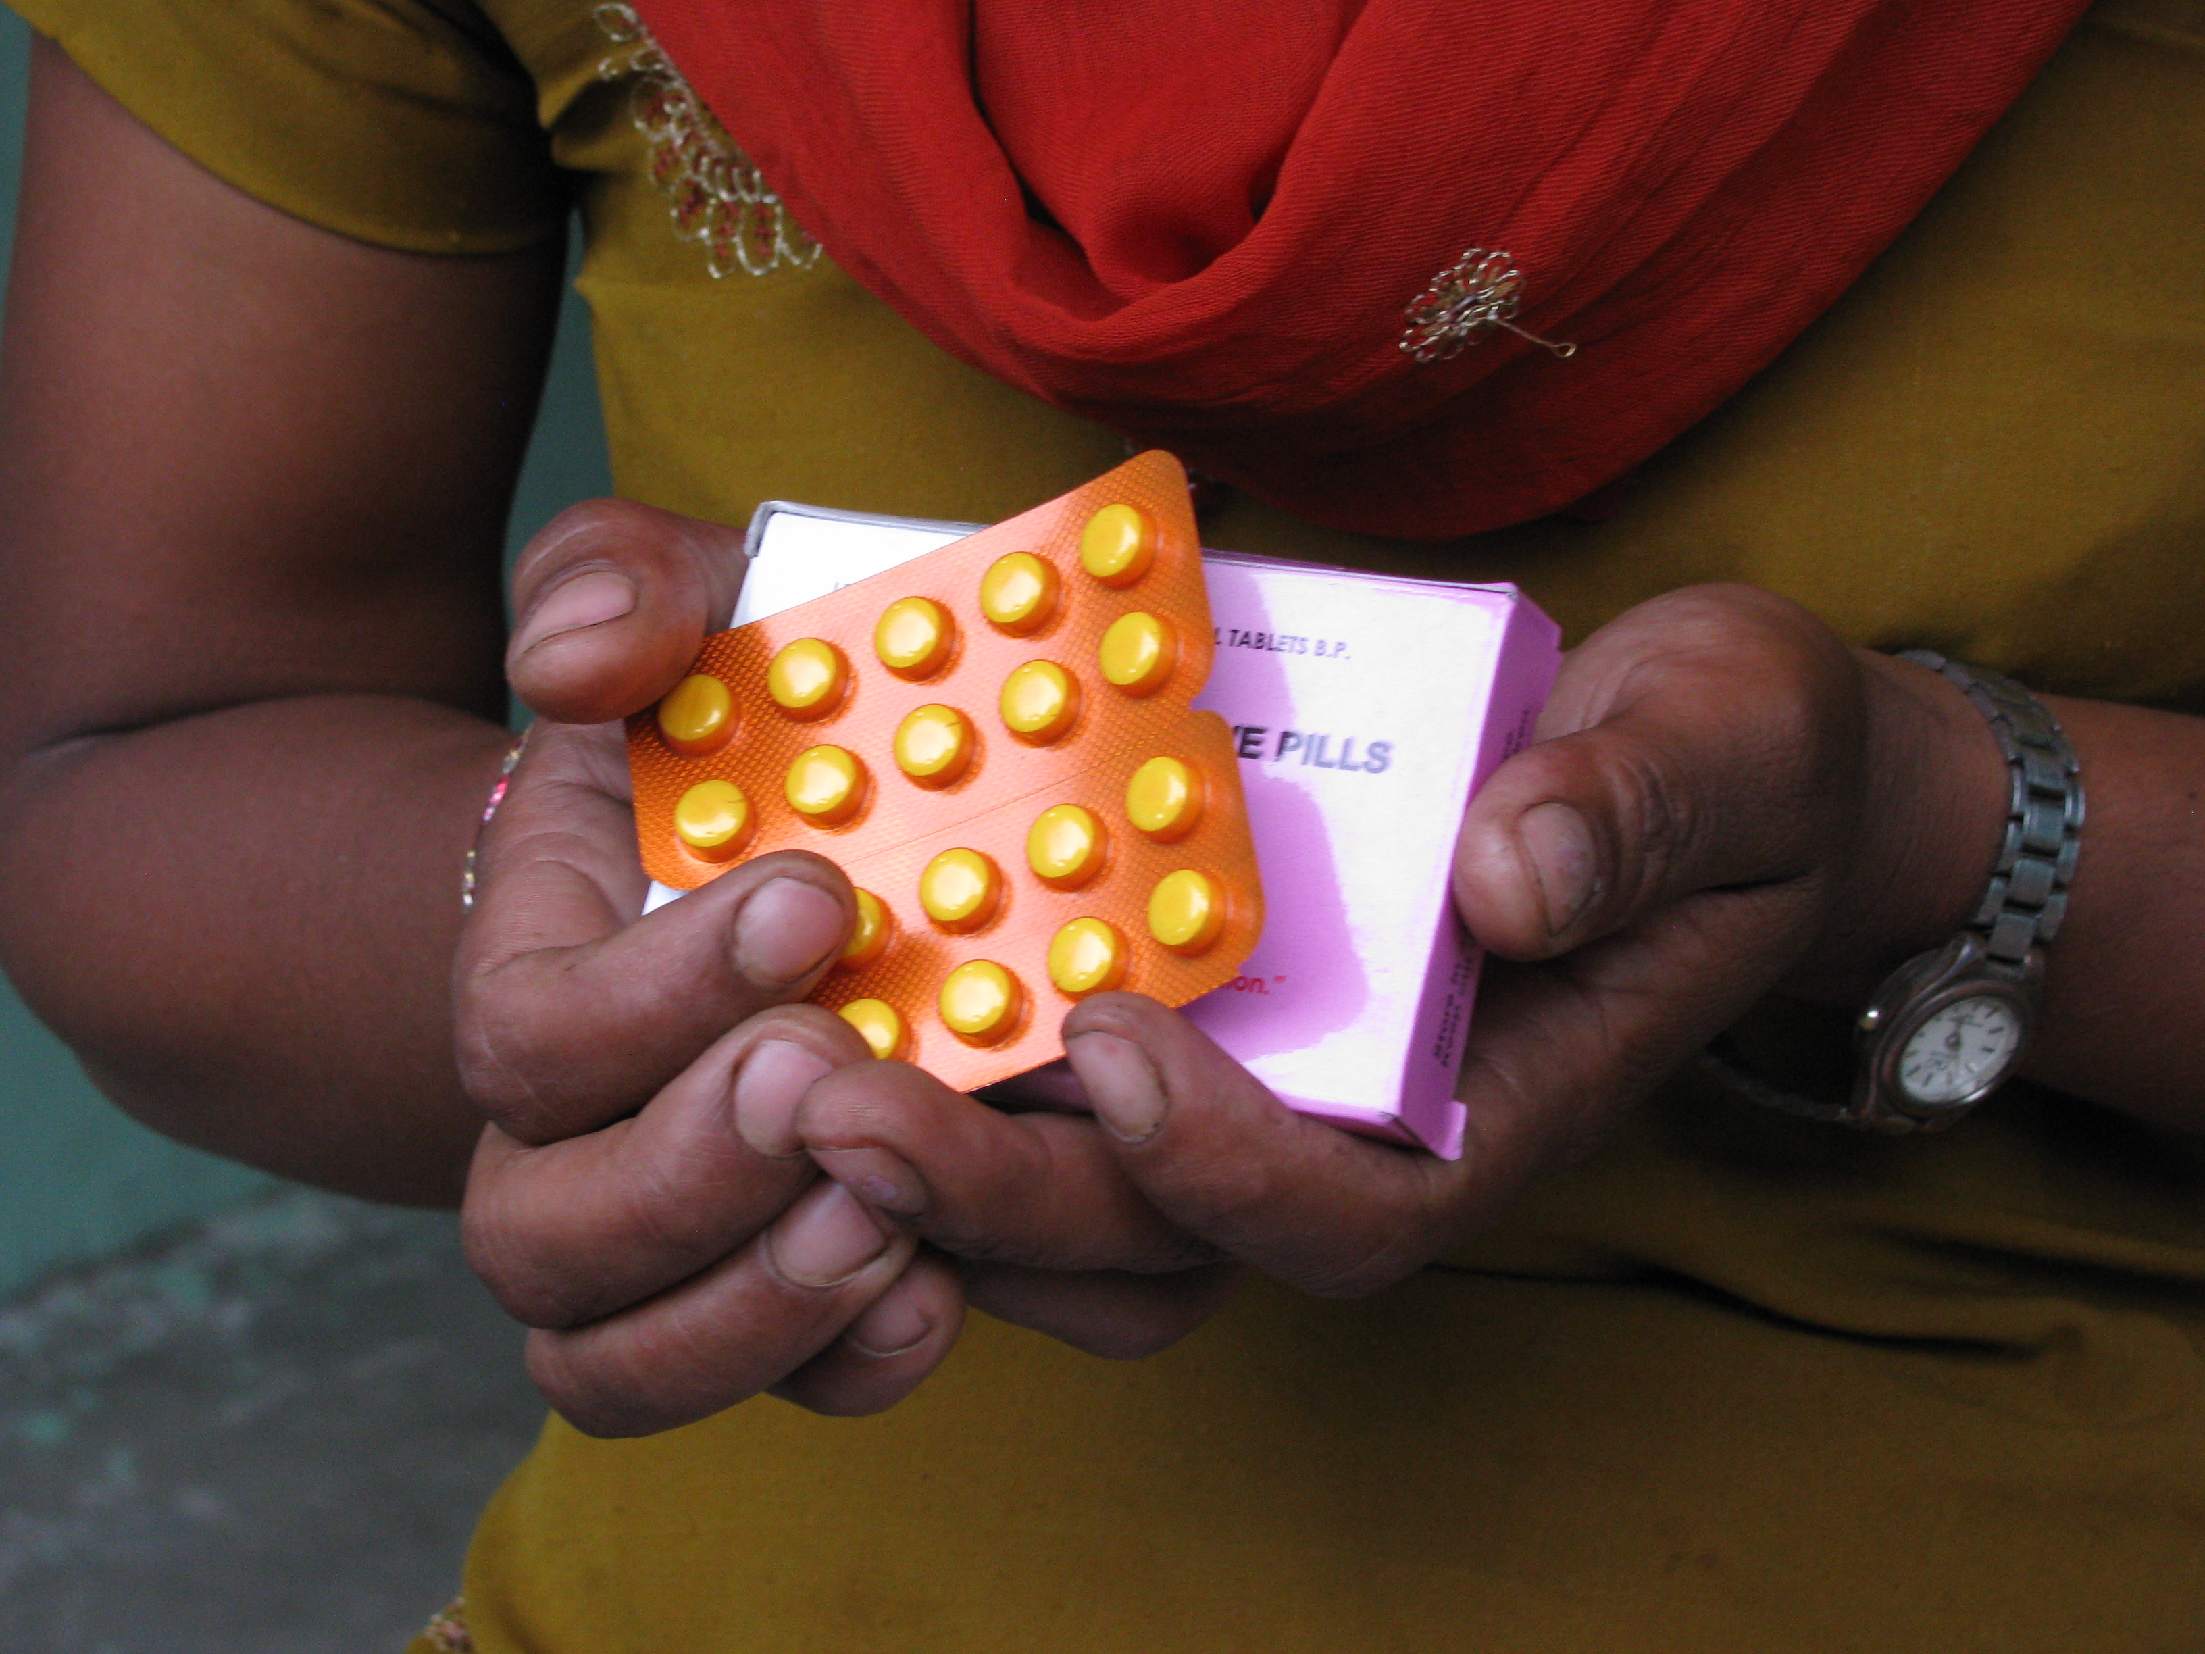

Templates from
Enhancing Contraceptive Security through Better Financial Tracking
A Resource Guide for Analysts and Advocates

USAID | DELIVER PROJECT, Task Order 4
The USAID | DELIVER PROJECT, Task Order 4, is funded by the U.S. Agency for International Development (USAID) under contract number GPO-I-00-06-00007-00, order number AID-OAA-TO-10-00064, beginning September 30, 2010. Task Order 4 is implemented by John Snow, Inc., in collaboration with PATH; Crown Agents Consultancy, Inc.; Eastern and Southern African Management Institute; FHI360; Futures Institute for Development, LLC; LLamasoft, Inc; The Manoff Group, Inc.; Pharmaceutical Healthcare Distributers (PHD); PRISMA; and VillageReach. The project improves essential health commodity supply chains by strengthening logistics management information systems, streamlining distribution systems, identifying financial resources for procurement and supply chain operation, and enhancing forecasting and procurement planning. The project encourages policymakers and donors to support logistics as a critical factor in the overall success of their healthcare mandates.
Recommended Citation
Rosen, James E. and Suzy Sacher. 2013. Templates from Enhancing Contraceptive Security through Better Financial Tracking: A Resource Guide for Analysts and Advocates. Arlington, Va.: USAID | DELIVER PROJECT, Task Order 4.

Abstract
This document includes adaptable templates for use with Enhancing Contraceptive Security through Better Financial Tracking: A Resource Guide for Analysts and Advocates. The guide leads readers through the steps to track contraceptive financing and finance processes. It provides information about financing schemes, sources, and agents and details how to collect and analyze data on how much funding was needed, committed, and spent for contraceptives. It also provides information to help users map the funding processes (including organizations involved, funding decisions, timing, and potential bottlenecks) in order to determine when and to whom to advocate for adequate and timely funding for contraceptives. Finally, the guide suggests various situations in which to use the finance tracking information to enhance advocacy and decisionmaking. The templates from this guide have been consolidated here and shared in Word in order to promote their ease of use.

Cover photo: Left—Hands of community health worker in Nepal holding oral contraceptives; Right—MSWord clip art showing calculator and pencil.

USAID | DELIVER PROJECT
John Snow, Inc.
1616 Fort Myer Drive, 16th Floor
Arlington, VA 22209 USA
Phone: 703-528-7474
Fax: 703-528-7480
Email: askdeliver@jsi.com
Internet: deliver.jsi.com

The authors' views expressed in this publication do not necessarily reflect the views of the U.S. Agency for International Development or the United States Government.

Contents

Worksheets and Tables
Defining the Commodities You Want to Track 1
Defining Contraceptive Financing Schemes in Your Country 2
Financing Agents by Main Financing Scheme 3
Sources of Finance by Scheme 4
Financing Schemes by Sources and Agents 5
Data Sources on Contraceptive Financing Commitments 6
Sources of Data on Spending on Contraceptives 7
Data Collection Plan 8
Funding Needs for Subsidized Contraceptives, Historical and Projected 9
Collecting Information on Commitments 10
Collecting Information on Spending 11
Amount Committed for Contraceptives by Funding Source, for Years of Analysis 12
Contraceptive Spending by Source and Financing Scheme 13
Describing Steps in the Contraceptive Financing Process 15
Identifying Advocacy Entry Points in the Contraceptive Financing Process 16

Interview Guides
Interview Guide for Collecting Information on Commitment and Spending 17
Interview Guide for Collecting Information on the Financing Processes 21

Defining the Commodities You Want to Track
Commodity | Will Track? (y/n)
Condom (male)
Condom (female)
Foam/jelly spermicide
Implant
Injectable
Intrauterine device (IUD)
Oral pill (combined)
Orals pill (emergency)
Oral pill (progestin only)
Standard days method
Vaginal foaming tablet
Female sterilization (associated equipment, instruments, and expendable medical supplies)
Male sterilization (associated equipment, instruments, and expendable medical supplies)
Other reproductive health commodity

Defining Contraceptive Financing Schemes in Your Country
Scheme | Exists for Contraceptive Financing  in My Country?
Government
Central government
Regional/state government
Local government
Social health insurance
Voluntary
Planned Parenthood National Affiliate
Other nongovernmental organizations (NGOs)
Out-of-pocket spending
Out-of-pocket spending

Financing Agents by Main Financing Scheme
Financing Agent
Scheme
Government
(e.g., central, regional, local, social health insurance)
Voluntary
(e.g., nongovernmental organizations)
Out-of-pocket
Sources of Finance by Scheme
Scheme  (from Defining Contraceptive Financing Schemes in Your Country table) | Sources of Revenue for Contraceptives (from table 7 in Enhancing Contraceptive Security through Better Financial Tracking: A Resource Guide for Analysts and Advocates) | Comments
Government
Voluntary
Out-of-pocket

Financing Schemes by Sources and Agents
Scheme | Source | Financing Agents

Data Sources on Contraceptive Financing Commitments
Funding Source (from  Sources of Finance by Scheme table) | Sources of Data on Commitments
Public (internally generated funds; transfers distributed by government from foreign origin; social insurance contributions)
Private (employers; households; nongovernmental organizations)
Foreign (in-kind; direct foreign transfers)

Sources of Data on Spending on Contraceptives
Funding Source (from Sources of Financing by Scheme table) | Sources of Data on Spending
Public (internally-generated funds; transfers distributed by government from foreign origin; social insurance contributions)
Private (employers; households; nongovernmental organizations)
Foreign (in-kind; direct foreign transfers)

Data Collection Plan
Funding Source or Agent | Source of Information  (from Data Sources on Contraceptive Financing Committees table) | Team Member | Steering Committee Member | Status
(WHO 2003)
Funding Needs for Subsidized Contraceptives, Historical and Projected
 | Analysis Year
Financing Scheme (from Defining Financing Schemes in Your Country table) | Needs for 2010 | Needs for 2011 | Needs for 2012 | Needs for 2013 | Needs for 2014 | Needs for 2015 | Needs for 2016
Government
Voluntary
Out-of-pocket
Total

Collecting Information on Commitments
Source of contraceptive financing commitment _____________________________________
 | Commitment
Method | Amount  (US$) | Date Committed | Commitment Start Date | Commitment  End Date | Destination of Funds (financing scheme) | Amount Committed for This Analysis Year | Source of Info | Comment
Total Committed

Collecting Information on Spending
Source of contraceptive spending _____________________________
Date of Transaction | Product Description | Quantity | Value | Funding Scheme Destination (recipient) | Source of Information | Comment

Amount Committed for Contraceptives by Funding Source, for Years of Analysis
Funding Source  (from Sources of Finance by Scheme table) | Committed for  Analysis Year 1  (e.g., FY2011) | Committed for Analysis Year 2  (e.g., FY2012) | Committed for  Analysis Year 3  (e.g., FY2013)
Public funds
Private funds
Direct foreign transfers
Total committed

Contraceptive Spending by Source and Financing Scheme
Analysis Year: _________ (month) ______ (year) – _________ (month) ______ (year)
Sources of Information: __________________________________________
 | Sources of Revenue |  |  |  |  |  |  |  |  | Total
 | Public |  |  |  |  |  | Private | Foreign
 | Domestic revenue | Foreign revenue |  |  |  | Social insurance | Out of pocket spending | Direct | In-kind
Scheme | Internally generated funds | Earmarked foreign | Non-earmarked foreign | Int’l loans | Other foreign funds
Governmental and compulsory contributory
Central government
State government
Local government
Social health insurance
Voluntary health care payment
Other nongovernmental organizations
External donors
Total

Describing Steps in the Contraceptive Financing Process
Name of funding source: ____________________________________
Step in Process | Organizations or Units Involved | How a Decision Is Made | Individual Decisionmakers or Implementers (organizations and titles) | Does This Step Take Place Regularly? | What Is the Timing of the Decision? | Potential Bottleneck
1.
2.
3.
4.
5.
6.

Identifying Advocacy Entry Points in the Contraceptive Financing Process
Financing process for (name of organization) _____________________________
Step in Process  (from Describing Steps in the Contraceptive Financing Process) | Potential Problem or Bottleneck | Possible Advocacy Goal
1.

2.

3.

4.

5.

6.

Interview Guide for Collecting Information on Commitment and Spending
Purpose of This Tool
This interview guide and accompanying worksheets will help you collect and record information on commitment and spending on contraceptives.
Using the Interview Guide
- Use one guide for each different financing source.
- Introduce yourself.
- Fill out basic information.
- Ask about each step in the financing process.
- Ask respondent to comment on any bottlenecks or problems.
- Thank respondent for their time and mention upcoming workshop.
Introductory Language
(This is suggested language; modify it as you see fit.)
Thank you for taking the time to meet with me today. I am part of a team collecting information on contraceptive financing in [country name]. I want to ask you a few questions that will help me understand the amount of money your organization commits to and spends on contraceptives. Your answers will help us mobilize and use resources better for family planning efforts.
Basic Information
Name of interviewer: ________________________________________
Place of interview: __________________________________________
Date and time of interview: ___________________________________

Respondent information
Name of respondent: ________________________________________
Title, position: _____________________________________________
How long in current position: _________________________________
Organization: ______________________________________________
Address: __________________________________________________
Email: ____________________________________________________
Phone: ____________________________________________________

Questions on Commitments
First, I want to ask you some questions about the amount your organization committed to spend on contraceptives. By commitment, I mean either a formal or informal statement of how much your organization planned to spend on contraceptive purchases for a specific period of time. I would like to ask you about your organization’s commitments for the past three years, beginning with [year].
- What quantity of contraceptives and amount of money was committed for these contraceptives?

Contraceptive | Quantity of Contraceptives  Committed | Amount of Funding Committed
Injectable
Implant
Intrauterine device (IUD)
Combined oral contraceptive
Progestin-only pill
Male condom
Female condom
Emergency contraceptive pill
Other (specify)

- On what date did your organization make this commitment?

- What period did this commitment cover? (ask start date and end date)

- Where were the funds that you committed going (government, other nongovernmental organizations (NGOs), etc.)?

Repeat for additional years, if appropriate. If information is available on commitments for future years, repeat the questions for those years.
Questions on Spending
Next, I want to ask you some questions about the amount your organization spent on contraceptives. I would like to ask you about your spending during the past three years, beginning with [year].

- How much did your organization spend on contraceptives during the year? What quantity of contraceptives did you procure with this funding?

Contraceptive | Quantity of Contraceptives Procured | Amount of Funding Spent
Injectable
Implant
Intrauterine device (IUD)
Combined oral contraceptive
Progestin-only pill
Male condom
Female condom
Emergency contraceptive pill
Other (specify)

- What details do you have for specific transactions when you purchased contraceptives (date, monetary amount, type of contraceptives purchased)?

- What was the destination of the funds that you spent (government, NGOs, etc.)?

Repeat for subsequent years, as appropriate.

Interview Guide for Collecting Information on the Financing Processes
Purpose of Interview Guide
This interview guide and accompanying worksheets will help you collect and record information on the financing processes for contraceptives.
Using the Interview Guide
- Use one guide for each different financing source.
- Introduce yourself.
- Fill out basic information.
- Ask about each step in the financing process.
- Ask respondent to comment on any bottlenecks or problems.
- Thank respondent for their time and mention the upcoming workshop.
Introductory Language
This is suggested language; modify as needed.
Thank you for taking the time to meet with me today. I am part of a team collecting information on contraceptive financing in [country name]. I want to ask you a few questions to better understand the process your organization uses to finance its purchases of contraceptives. Your answers will help us better mobilize and use resources for family planning efforts.
Basic Information
Name of interviewer: ________________________________________
Place of interview: __________________________________________
Date and time of interview: ___________________________________

Respondent Information
Name of respondent: ________________________________________
Title, position: _____________________________________________
How long in current position: _________________________________
Organization: ______________________________________________
Organization’s fiscal year: ____________________________________
Address: __________________________________________________
Email: ____________________________________________________
Phone: ___________________________________________________
Questions for Respondent
My main interest is to understand the details of the reproductive health commodity financing process, starting with identifying financing needs beginning with getting the product into the country and distributing it to clients. For your organization, please describe each step in the contraceptive financing process, in chronological order.
Step 1: ______________________________________________________________________
- What name do you use for this step?

- What are the organizations, units, and individuals involved in this step?

- How is the decision made at this step?

- Who is (are) the decisionmaker(s) at this step?

- What is the timing of this step? Does it take place regularly (e.g., monthly, quarterly, annually)?

- Do you have any documents that describe this step—or the process more generally? If yes, are copies available (an electronic copy is preferred)?

Repeat these questions for each step, until you have completed all the steps.

- What do you see as some of the main bottlenecks or problems in the financing process?

For more information, please visit deliver.jsi.com.
USAID | DELIVER PROJECT
John Snow, Inc.
1616 Fort Myer Drive, 16th Floor
Arlington, VA 22209 USA
Phone: 703-528-7474
Fax: 703-528-7480
Email: askdeliver@jsi.com
Internet: deliver.jsi.com

